**Question on Conduit calculations:** **1**

# Question: calculate the tabulated current

A 5.5A load has a conductor protected by a 6A mcb and has the following correction factors applied to it:

Ca = 0.94 & Cg = 0.6

Calculate the “tabulated current” required.

When it says “tabulated current” it only wants you to calculate the up to the **It**

# 

# 

# Question on Conduit calculations:

The following cables are to be drawn into a straight 2 metre length of conduit:

* 2 of solid core 1.5mm2
* 4 of solid core 2.5mm2
* 4 of stranded 4mm2

Calculate the conduit size required to accommodate these cables?

**Workings out:**

* The wires core. Which means the copper wires inside of the insulation can be solid or grouped together as strands. Stranded wires provide greater flexibility than solid ones.
* Sometimes the question will specify the length **E.g. 2 metres**. Otherwise it will specify **Short**.
* For cable factors in short straight runs use table E1.

**Step one - use table E1 to get the cable factor**

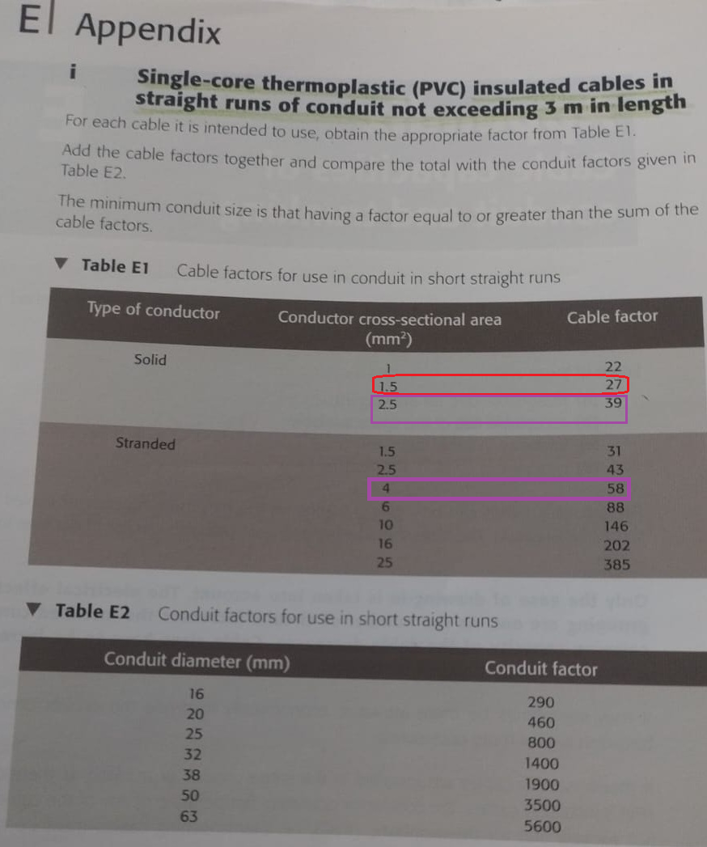

**Step two - create a table to calculate the total cable factor**

| **No. of cables** | **size** | **Cable factor** | ([**No.**](http://no.of) **of cables** X **Cable factor**) |
| --- | --- | --- | --- |
| 2 | 1.5 | 27 | 54 |
| 4 | 2.5 | 39 | 156 |
| 4 | 4 | 58 | 232 |
|  |  | **Total Cable factor** | **445** |

**Use the total cable factor to look-up the conduit factor.**

Go to **Table E4**. As a side note I know that the question clearly states “Straight 2 metre length” which is a short straight run. Therefore, why would we use **Table E4** which is for long runs?

However, the left corner stipulates **“Covered by Tables E1 and E2”**.

But, it cannot be **Table E1** because we used it for the cable factor calculations hence it must be **Table E2**.

We use the total cable factor 445 and round it up to the nearest value in the Conduit factor column which is 460. We can look-up this value in the conduit diameter (mm) column so that value is 20(mm).

